SEABROOK McKENZIE CENTRE

SPECIALISTS IN SPECIFIC LEARNING DISABILITIES
68 London Street, Richmond, Christchurch 8013 Phone: (03) 381 5383 Email: info@seabrookmckenzie.net
Seabrook McKenzie Certificated Teacher -Tutors
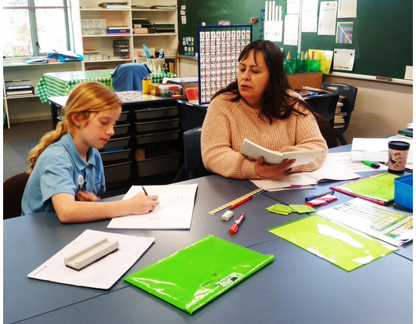

Who tutors?
The Seabrook McKenzie Centre has a network of certificated, self-employed teacher-tutors who have had specialist training in Specific Learning Disabilities. These teacher-tutors provide tuition to address underpinning issues associated with learning difficulties such as dyslexia, dyspraxia, dyscalculia and dysgraphia. Teacher-tutors, certificated with us, are trained to teach all learning needs, as well as literacy needs, with structured, sequential, explicit programmes to suit the individual needs of the student.

Where?
Either at the SLD teacher-tutor’s home or in some cases at the student’s school, or at the Seabrook McKenzie Centre. That is decided by mutual agreement with the teacher-tutor.

When?
The duration and frequency of the lessons vary depending on the age and needs of the learner, but is usually one hour per week, preferably in school time, particularly for young or distractible children.

How is quality assured?
Seabrook McKenzie Centre teacher-tutors abide by the Code of Ethics and the quality control policies of the Centre. They undergo professional development and are supervised by the Centre. Teacher-tutors we recommend, are required to have a Seabrook McKenzie Practising Certificate if they wish to have students referred to them by the Seabrook McKenzie Centre. The Practising Certificate must be renewed every three years: during which time the teacher-tutor undergoes successful professional development. Students are reassessed to check progress and adapt the programme if necessary. If in doubt, please contact us to check if a teacher-tutor is certified by us.

What?
Each teaching programme is based on the information in the student’s formal SLD report and the teacher-tutor’s professional judgment based on diagnostic teaching. The programme is individually designed to accommodate the student’s particular learning needs. The programme is responsive to the student’s progress, strengths and weaknesses, and is structured, sequential, and explicit.

Note:
While every effort is made to find teacher-tutors for students needing tuition, we cannot guarantee immediate placement and some students may have to go on a waiting list.

